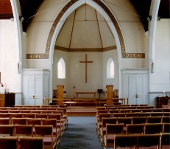***THE AVENUE***

**STANFORD AVENUE**

**METHODIST CHURCH,**

**BRIGHTON**

June – July 2022

**Minimum Donation 50p**

**THE AVENUE**

**Minister: Revd Dan Woodhouse Tel: 01273 508704**

**E-mail: revdanwoodhouse@gmail.com**

**Church Office Answer Phone: Tel: 01273 554141**

**E-mail:** **stanfordmethodist@btconnect.com**

**Assistant to Minister: Major Connie Croly: Tel: 01273 875376**

**Editor: Martyn Coblenz: Tel: 07724 605610**

**A Letter from our Minister**

**Tradition and Betrayal**

I found out this week, in passing (which is what you get for hanging around a university), that the words ‘tradition’ and ‘betrayal’ are closely linked. The person casually remarking alluded to the idea that you can’t have tradition without betrayal. He meant that a tradition can’t be handed over from one generation to the next without there being a betrayal of the way that tradition was held

and experienced by the previous generation.

I went to read up about all of this and it somewhat made my head spin; lots of long words in explanation! So I can’t explain to you exactly how this works or how closely the ideas are linked. For sure the two words have shared origin, so at the very least I’d like to run with the poetry of tradition needing betrayal.

I pick this idea up in this article, as, for me, it immediately spoke into the traditions of Methodism, our circuit, our church, and the longing that I know there is for our traditions to be handed onto the next generation; just like how the current generation received them from the previous generation.

First, I wonder if you can remember how people did things before you? I suspect you can. I wonder if you have continued to do things the same way as that previous generation? I suspect not! Therefore, you have lived out the betrayal of tradition.

Of course, this is no bad thing, because, significantly, the tradition has continued. So, I’m sure the previous generation looking down on us would forgive the changes given that the tradition remains intact.

However, we all need to recognise that there is pain here. There are ways of doing things that were held as important, significant, perhaps even sacred, that were trampled by the betrayal of the tradition being handed over. The only way a generation can be comfortable with this is to have faith and trust in God that the new generation will continue to faithfully live out the tradition albeit in a new way.

I had a somewhat personal experience of this recently. It’s very different from church tradition, but I think the emotions were similar. My grandad died when I was ten years old. A couple of years later, all the children and grandchildren, for some reason that I did not know and in no way question, received a few hundred pounds. I was in my early teens by this point and my parents said I could put the money into savings, or I could get a new bike. I won’t insult your intelligence by telling you which of these I punted for.

It was red and yellow, looked amazing, and I rode it A LOT. I did a paper round seven days a week, I rode to school and back most days, I rode to my friends’ houses several times a week. When I got to sixteen, I rode it to 6th form and my part time job. I was so comfortable with the bike that I would often ride it from work to my house, which was about two miles of streets, and corners, without ever touching the handlebars. So, I became very sentimentally attached to this bike. I have then kept it with me all the way up to moving to Brighton. The problem has been that since growing up it’s just too small for me. It was uncomfortable to ride. Despite this I have been very reluctant to lose it from my life; but lose it I knew I must. I knew that there was someone, some teenager somewhere, who would have good use out of this bike. However, would they care for it in the same way I cared for it? I know they wouldn’t have the memories of tearing around West Park in Long Eaton on it, they wouldn’t know that the money to buy it came from my grandparents, they might even lose it, or break it. I would be betrayed in the handing over of the tradition of this bike. However, the only way this bike would ever be of use again would be by letting it go. So, I did. Andy Lowe picked it up explaining that there’s a family that will be very blessed by this bike.

I haven’t seen it since, and so I don’t know how it’s being used or cared for, but I do have faith that it’s being used well. So, I am sad for not having the bike anymore, thankful that I had it at all, and faithful that it has an opportunity to be of use once again. I now have a new bike which is not yellow, so is therefore not as good. The frame is also a standard boring frame. It is practical though, which I guess is probably good.

I write this, because the more we explore our future as a circuit and a church the more I realise that there must be a betrayal of the current generation. Things will look differently, and it will be painful. I think in some ways this is obvious, so I feel like writing this is patronising. However, significantly I think the handing on of our tradition this time will see the most radical changes and therefore be the most painful for the current generation to endure. However, I think this pain in the end must be endured.

(It’s worth noting here that when we start to apply the word generation to our context that we remember that many of us span different generations and might even have the age of one generation but the insight and/or feelings of another. So, in our context I use the word very broadly and probably quite ambiguously.)

You may think I’m being flippant in saying that the pain must be endured, as it’s not my pain to endure. Which to some extent is probably true. However, there’s a tension I’ve noticed that will at some point snap. Either in the appeasement of the current generation’s very understandable reluctance to be betrayed or by the next generation inflicting the pain onto them regardless.

In explanation it’s worth taking the example of some of the open circuit ideas meetings we have had. Some meetings have started with the premise that things need to change, and everyone agrees. Then we spend the meeting constructing a new idea, but by the end the new idea is the same as what we are already doing. Which makes sense because we know what we know and are comfortable with what we know.

The circuit leadership team, though not just this group, then go away and try to plan change whilst also keeping things the same. At some point this contradiction will resolve itself one way or another.

I guess I wrote all of this, not because I think I’m teaching or pointing out something new. Instead that I hope we may be mindful of what we know must happen if our tradition is to continue, and of course any tradition we might hold dear inside or outside of the church.

The current generation must be ready to experience the pain of betrayal and have faith that the tradition will continue. The new generation must recognise this pain and be mindful of the needs of the current generation. However, we cannot be mindful of this pain at the expense of the continuation of the tradition. The betrayal must happen sooner or later.

Blessings

Dan

**PRAYER.**

Goodness is stronger than evil

Love is stronger than hate

Light is stronger than darkness

Life is stronger than death

Victory is ours, victory is ours through him who loves us

Hallelujah!

(Words by Bishop Desmond Tutu)

**PINEAPPLE UPSIDE DOWN CAKE.**

Ingredients.

4oz Butter or Margarine

4oz Castor Sugar

2 eggs Beaten

8oz Self Raising Flour

Milk As needed

Topping

4/5 Halve Glace Cherries

1 Tin Pineapple Rings, drained

2Tbsp Golden Syrup

Grease well an 8” tin (No loose bottom) I use a straight sided Pyrex dish.

Cream together the butter & Sugar. Add eggs and flour alternately and enough milk to make a smooth batter.

Put 2 tbsp Golden Syrup in the cake tin and place in the oven until the syrup melts and covers the bottom of the tin, then remove from the oven.

Place the drained pineapple rings in the base of the tin and add halved glace cherries to decorate the pineapple.

Add the cake mixture onto the pineapple and cherries and smooth the top.

Bake in the centre of the oven for approx. 1 hour – test frequently 180 degrees /350Degress F/Gas 4.

Cool for a short while then turn out onto a cooling rack.

This can be eaten warm as a delicious pudding or cool completely for cake.

**ST GEORGE’S DAY MEAL**

St George's Day Meal 23rd April 22.

It is always great when the church comes together. But this was extra special. Two plus years ago we sat and ate together at the excellent murder mystery evening. A few days later the first Lockdown began.

How lovely to be back together and celebrating our countries, Patron Saint.

And what a fun evening it was.

Of course special mention must be made to thank John, Karen and team for the tasty meal, and the generous donation of the food, and their time cooking and preparing. We very much enjoyed Dave 's quiz (we won't mention winning...oops). But of course the highlight (well for me) was watching Rev Dan and Connie dance....we use that term loosely. Thanks to Esther for being brave enough to instruct all the dancers.

Again thanks to all involved

Also....

Did you know St George was only adopted as England's Patron Saint 1n 1350 by Edward III

It is thought he was probably Turkish. Martyred in AD 303.

The Dragon, from the story represents the Pagan Roman Empire.

Before St George our previous Patron Saint was Edmund the Martyr. Edmund was born on Christmas Day 841AD in East Anglia.

St George's Day is also the Birthday of William Shakespeare

Rob

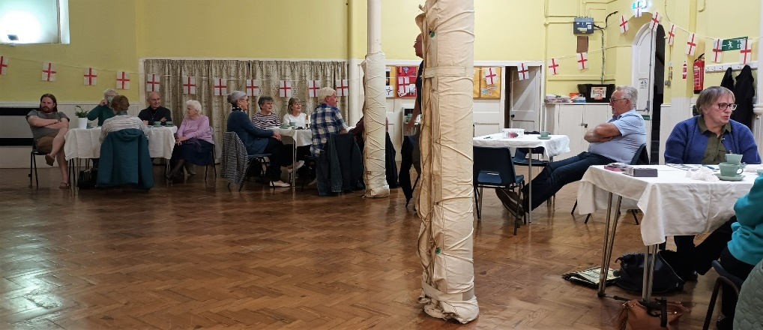

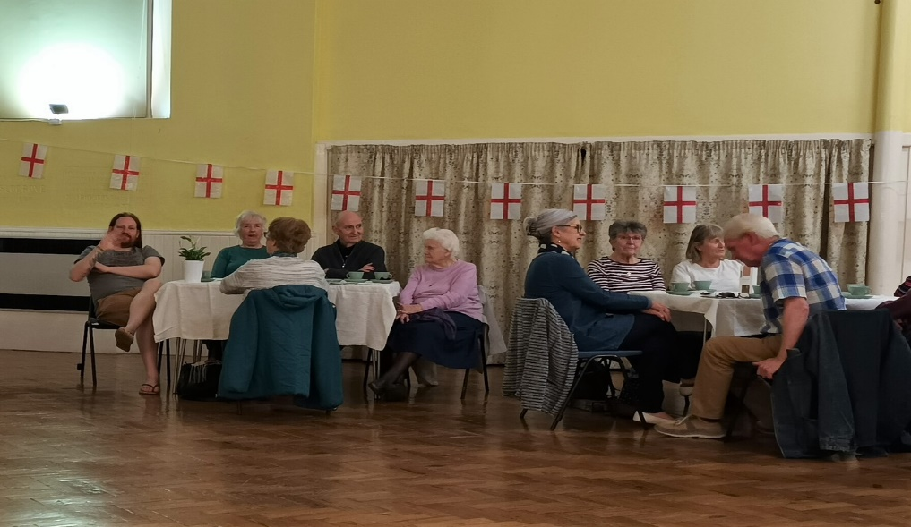

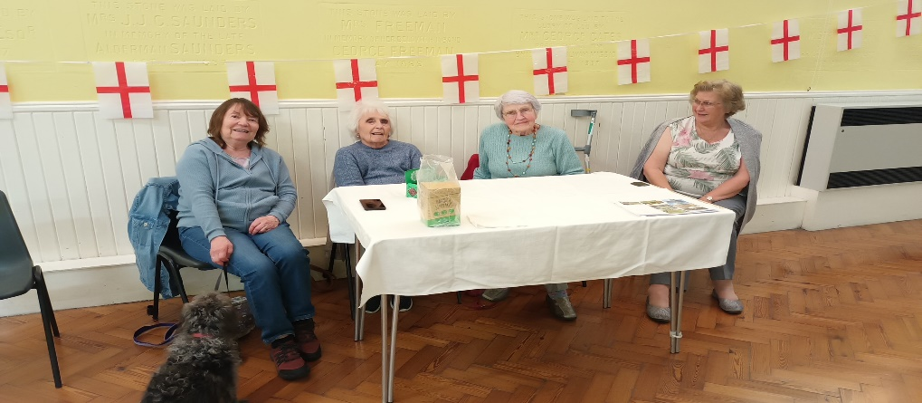

*Martyn – Thanks for this Robert, it certainly was a very good evening*

**MEDITATION & MUSIC.**

The date of the next Music & Meditation has been changed from the 15th June to 22nd June 2-30 – 4-00pm

Best wishes Sylvia Lord.

**PRAYER**

Lord Jesus Christ

You have put your life in our hands

Now we put our lives in yours

Take us, Shake us, Remake us

No longer is what we have been important

It is what, with you, we can be, starting now

Amen

**STEWARDS AT STANFORD AVENUE**

Coming and Goings

I thought now would be a good time to write a bit about the Stewards and what the Stewards do.

Firstly the goings. Both Des Pierce and Ann Nealer have recently stepped down (well Des during the Pandemic) . But now is a good opportunity to thank them for their work as Church Stewards over a number of years. They have both been steady hands at the Churches helm and will be greatly missed. Thank you for all you have contributed over the years!

We are very pleased to have Malcolm Robinson join us.  He joins our team along with Jeni Stevens , Lis Coblenz and Cath Odd Haywood ( Cath has of course not been well, but we are very much looking forward to her return )

We would however like to see more Stewards join us...

So what do the Stewards do?

You will of course see the Steward at the front every Sunday. On Sundays the Steward is there to prepare and support the worship leader.  Opening and closing the Church, getting the sound system up and running. Prayers for and with the worship leader and notices. Although for me the biggest privilege is to support the minister with Communion.

In the past counting the money, but currently Jeni very kindly sorts that on our behalf. A huge thank you Jeni.

The other side of Church Stewardship is the supporting of the minister, and the church (Planning, liaising with groups, etc) . This is hugely rewarding, and very varied. We all have our own skills, and it is an honour to be able to use these in supporting the running of the church, and in a broader sense the circuit. We usually meet every six weeks or so, this has proved difficult recently, but we hope to get back on track soon.

If you have time, please consider becoming a steward. Your Church needs you !

Feel free to speak to me if you would like to consider stewardship.

Robert Patching

Senior Steward

*Martyn – Please, please do think & pray hard for this very important role within our Church.*

**CHURCH FAMILY NEWS**

We continue to pray for June Lawson, Nadine & Gary Pugh, Ann Collins, John Pollard (Vic & Margaret’s Son), Sylvia & Ray Smith, Debbie Johnson, Jean Griffin, Doug Butler, Liz Wakeling & Amy Codling (Leaders of Scouts & Girls’ Brigade), Phil Codling, Ian Codling, Maureen Knell, Sheila Whyte, Jean & Geoff Starks, Wynn Funnell, Gill & Shirley Challen and Margaret Trengenza.

Sadly we have heard of the passing of Syd Beck on 17th May. There is a Cremation Service at Woodvale Crematorium Friday 10th June @ 11-00 and there will be a Memorial Service at the Church at 12-00 on Friday 10th June. All are welcome to celebrate the life of Syd both at the Crematorium & The Church We pass on our condolences to Hazel, Robin & Derek and all their families.

As always, please let me know if you want me to remove any names, add to them or update us with news of any of the above.

We of course continue to pray for our Circuit staff as they minister to us – namely – Revd’s Andy Lowe, Deborah Cornish, Dan Woodhouse, Heather Leake Date, Major Connie Croly, Sue Harrington, and all our Lay Workers and Local Preachers.

**TEA & SCONES**

Please invite friends & family to this event. Everyone is welcome.

**FUNDRAISING UPDATE.**

How time flies!!!

Already it’s June and we were hoping the friends of Blakers Park would be holding a Summer Fair, but apparently not this year.

The St Georges Day meal was a great evening with a delicious meal and lots of different entertainment. Thanks to Karen & John Patching for their generosity. The evening made £389

Our next event is a quiz on 2nd July at 4-00 pm in the Church. The earlier starts for our events are working well, we hope you agree. If you would like come, it will be £10-00 for a ploughman’s style meal, plus, of course, cake. Robert will be our question master for the event. Book your place with Lis on 07730 0773891 or see Amy, Jeni, or Lis at Church.

We need your plastic flower pots!!

A box is in the Fellowship Room for your **CLEAN** pots, any size. We need lots!!!!If you know any local community groups that would like to get involved, let Lis know. You may think “How can you make a sculpture from Flower Pots?”

If you Google – Settle Flower Pot Festival – you will see some amazing creations and get an idea of what we are planning. The Festival will be on Saturday 24th & Sunday 25th September. The Church will also be holding our Harvest Festival on 25th September.

Have a look at the simple ones that Karen & Lis made to get an idea.

*Martyn – Come on all you budding sculptures. You would be helping to recycle those plastic pots as well.*

Hope you ladies have got the Fashion Show booked for Friday 14th October in your diaries. It promises to be a fun evening with an opportunity to buy after the show. Tickets will be available very soon.

Too soon to talk about Christmas. Never!

The Christmas Fair will be on 26th November. Start collecting your unwanted gifts and gift bags for a bumper stall. Other things will of course be needed nearer the time.

*Martyn – Thanks once again to the Team. Please give your support to as many as you can.*

**Dates for your diary.**

2nd July Quiz @ 16-00

24th/25th September Flower Pot Festival

25th September Harvest Festival

14th October Fashion Show for the Ladies

1st November All Saints Service 19-30

26th November Christmas Fair

**ACTION FOR CHILDREN**

This April I was lucky enough to attend my daughter’s graduation at the Brighton Centre, she, like many others was a mature student juggling studies with family life. This was an open university ceremony which enables people from all walks of life to achieve their educational potential. It was truly inclusive. Some mums and dads took their children on stage with them to receive their awards. Having been a mature graduate myself I know the feeling of immense achievement having reached the potential that was always inside.

Helping people reach potential is something I have been lucky to have been part of in my time as nurse lecturer with nurse students. Also, with patients helping them to achieve their best sight potential. Now with my mum I help her to achieve her potential maybe to hold a cup or enjoy her food it’s about enabling others to reach their goals, about releasing that potential big or small.

Jesus in LUKE 10 V 38-42 Says to Martha, who is cross that her sister Mary is sitting at the Lord’s feet listening to his teachings, “Mary has chosen what is better and it will not be taken away from her.” Illustrating that learning is important to all. How lucky we are to have the opportunity to learn.

Action for children runs a programme called the Blues Programme, for 13–19-year-olds, who suffer from or are at risk of developing a mental health condition. Blues Busters deliver the programme in schools over 6 weeks including a mixture of cognitive behaviour therapy, coping strategies and physical activities. Poor mental health should not be a barrier to any young person fulfilling their potential. AFC delivers the Blues Programme in 150 schools and to more than 5,500 children.

**Dates for diary** Coffee morning Saturday 9th July 10:00 Stanford Avenue in aid of AFC. Please come along and support the great work of AFC.

There will be a speaker from AFC at Stanford Avenue in September date to be confirmed

*Martyn – Thanks for this Gaynor.*

**WHO AM I?**

I am Brighton Born

I have 3 siblings

My earliest memory is playing skipping in the street

My wedding anniversary is on Independence Day

I have lots of Hobbies, but I like to play Scrabble and read every night before I go to sleep.

I first came to Stanford Avenue in 1980

I have served only once as a Steward

My favourite food is smoked salmon

If I could meet anyone famous, I would like to have met Maya Angelou

You may not know, but I would like very short hair

**NAILS**

Matthew 2: 1 – 18

My name is Meliakim. I work metal. Have done for years.

Usually on Friday you’d find me in my shop, smelting down the ore, forging the metal.

Nails. That’s my bread and butter. Nice little contract for nails, with the Romans.

Usually you’d find me there about this time on a Friday.

But not today. Oh no. I’ve waited too long for this, laid awake too many nights, cried too many tears.

And all because of you, Jesus. The Christ!

He’d be about your age now if he’d lived.

Ironical, isn’t it? We’d called him Joshua too, just like you.

‘The Lord saves’.

The Lord saves? How did he save our Joshua? Where was his saving power when the soldiers came in the night, burst into our room brandishing swords and clubs, and killed him before our eyes?

God almighty, he wasn’t even two years old!

It was only later I learned that Herod had ordered all the boys under two in our district to be killed.

We lived in Jerusalem then, and Herod had been told a child who would be King had been born there. Red rag to a bull.

Such misery I have never seen. They say the blood ran red in the streets for that boy.

They say the screams of the mothers could be heard the other side of the Jordan.

I vowed that night I would see that child die.

My wife never recovered from the shock.

She died delivering our second child. The child was stillborn.

And since that day over 30 years ago, my whole life has been eaten up with bitterness towards the child born to be King.

So finally, here we are. Face to face.

I watched the soldiers hammer the nails – my nails – into his left hand and I cried out **‘that’s for my son!’**

And when the nail – **my** nail – went through his right hand, I cried **‘that’s for my wife!’**

It’s strange, I thought I would gloat. I thought I would feel some great surge of satisfaction.

But when he heard me cry out, he raised his head.

It was the first time I’d really looked at his face.

He didn’t look like I expected. I thought he’d be proud, self-satisfied, smug even. Most Kings are – oblivious to the suffering they’ve inflicted, cushioned from how they make their people suffer. But he wasn’t.

There was more suffering etched on his face than you could imagine.

Not just his own suffering – God knows that was bad enough.

No, somehow, he seemed to be carrying… carrying the suffering of the world. My suffering.

I looked at the nails. I thought of how I’d worked them in the forge.

Red hot, white hot. And suddenly I felt the same heat, red hot, white hot, surge through my breast – and all the bitterness of the years was burned away, in one unbelievable moment. I closed my eyes and gasped.

The power of the moment had taken me by surprise. I did not think it possible to forgive and be forgiven in the same instant.

But that’s what happened.

When I opened my eyes, he was dead.

Adrian Newman

© 1997 The Council of Churches for Britain and Ireland and individual authors.

*Martyn – Thanks to Geoff Harrington for this item.*

**MATHEW BLACK FITNESS RAISES £100 FOR CHURCH APPEAL.**

Inspired by Stanford Avenue Methodist Church Ukraine fundraiser. Matthew's community ran a special one-off Friday evening UV dance party. All profits went towards the collection for Christian Aid. The UV lights added a really exciting atmosphere to the night, and some long-term clients felt confident to try dance fitness for the first time (mainly because on one could see them under the UV lights). It was agreed by everyone that more UV parties should be added to the calendar.

Further community engagement will continue next month as Matthew brings out his Circuit training equipment for the Cubs and Scouts. Along with water rowers and spin bikes, there will be free weights, resistance bands and glide pads. For many this will be the first time they have had the opportunity to experience this sort of activity. Matthew loves the enthusiasm the Cubs brought to his activities in the past and hopes that he will persuade some of these young people to take a break from their screens and start the social, happy and healthy group fitness habit.

*Martyn – Thanks Matthew Keep up Your Good Community Work.*

**JOKES.**

1. What do you call a Pig that does Karate

**Pork Chop**

1. Why did the bike fall over

**It was too tired**

1. Why did the golfer bring two pairs of trousers

**In case he got a hole in one**

1. What did the policeman say to his belly button

**Your under a vest**

1. Why did the man get hit by a bike everyday

**He was in a vicious cycle**

1. Why do seagulls fly over the sea

**If the flew over the bay, they would be bagels**

1. What do you call an alligator detective

**An investigator**

1. Why shouldn’t you wite with a broken pen

**Because they are pointless**

1. What’s brown and sticky

**A stick**

1. Why do bees have sticky hair

**Because they use honeycombs**

**FUNNY SAYINGS**

What do you get if you crossbreed a cow and a shark

**I don’t know, but I wouldn’t enjoy milking it**

What is pointless

**To tell a bald guy a hair-raising story**

Why do bees hum

**They don’t remember the words**

What do you call a boomerang that doesn’t come back

**A stick**

Why are eggs not into jokes

**Because they could crack up**

How many men were born in 2017

**None, because they were babies**

What are a sharks two favourite words

**Man overboard**

Where do fish sleep

**In a River Bed**

What did one plate say to his friend

**Tonight Dinners on me**

Chocolate is the best investment

**You buy 100 grams and gain 2kg**

**LAST DAY for AUGUST – SEPTEMBER 2022 magazine contributions will be WEDNESDAY 20th JULY.**

You will be able to send contributions via E-Mail: stanfordmethodist@btconnect.com, or, by post to Stanford Avenue Church with ‘For Magazine’ on the front of the envelope.

**CONTRIBUTIONS NEEDED.**

Please, please, please send me your items for the Church Magazine. Especially as Wynn had finished her item on being a Red/Bluecoat. If I do not receive items, it may not be worth producing. I’m sure that some of you have some very interesting stories or items that others would be interested in.

Please send them to the stanfordmethodist@btconnect.com or drop them through the Church letterbox.

**PAUSE FOR THOUGHT**

As I write this on a lovely sunny day sitting in my armchair looking out of the window, it’s so quiet and peaceful. I’m preparing to go and speak at a meeting this afternoon. As it’s Mother’s Day this coming Sunday I plan to look at Mary and her son Jesus, from his Birth to his Ascension.

Now I’m back home reflecting on the meeting. Before I spoke, we had a time of prayerful silence occasionally broken by someone praying. In the silence, despite being near a main road with lots of traffic, we could hear birds singing just outside. It was a wonderful, uplifting time, and I still feel that peace now I came down to earth as I prepare to watch the news.

So, half an hour later and I have seen terrible scenes of suffering and death from UKRAINE So many people of all ages being killed and injured. Then I looked at my paper to read about many people offering sanctuary to people fleeing from the horror, opening their homes to total strangers. Also there are articles about many exhausted NHS workers who have to force themselves to keep going. Another piece on the backlog of patients waiting for operations and treatment delayed by Covid. How do we deal with this? Obviously, we pray for these totals strangers. But we need to find time to “Switch Off” to relax.

Recently I discovered UNWIND with I.T.V. It’s a daily escape designed to calm the mind and encourage relaxation and reflection. It lasts about 20 mins. Scenes of Countryside, Sea, Rivers, Towns. There is music, which I mute. Problem is it’s on in the early hours, so I record it to watch whenever I feel the need. I recommend it.

In the last magazine I quoted from the hymn “What a Friend We have in Jesus” but not the first verse. I write that now.

What a friend we have in Jesus

All or sins and griefs to bear

What a privilege to carry

Everything to God in prayer

O what peace we often forfeit

O what needless pain we bear

All because we do not carry

Everything to god in prayer!

So, we continue on our journey praying for each other and for those in need wherever they may be.

May God Bless us all.

Wynn

*Martyn – Thanks Wynn again with your thoughts.*

**Dates for your Diary @ Stanford Avenue.**

2nd July Quiz @ 16-00

9th July AFC Coffee Morning 10-00 am

24th/25th September Flower Pot Festival

25th September Harvest Festival

14th October Fashion Show for the Ladies

26th November Christmas Fair

**ANSWER TO WHO AM I.**

**ESTHER HARRINGTON**

Look out for the next one in the August/September issue.

**advert**

h b c

For bathrooms

195 Church Road,

Hove BN3 2AB

Tel: 01273 730149

Fax: 01273 207438

For top quality bathrooms & showers, retail only or full design & installation

(family business)

Directors: Michael Bellis, Marilyn Bellis & James Houldcroft

ACTION ROOFING SERVICES LTD.

**Specialists in all types of Roof Renewals & Repairs**

**Tiling – Slating – Felting/Asphalting**

**Free Estimates**

**12,Plainfields Avenue**

**Brighton BN1 8RJ**

**Telephone: 01273 555535**

**www.actionroofingservices.co.uk**

**K. H. Tahsin**

Retired decorator looking for a bit more work

**01273 419914**



We offer friendly, professional

care in your own surroundings

**All our staff are fully COVID vaccinated**

**We are a local Fiveways family run company**

**We can help with**

**Washing and dressing**

**Making meals**

**Cleaning and shopping**

**Taking you out to an appointment**

**or out for the afternoon**



▼

▼

▼

▼

01273 542200

www.hallifaxcare.co.uk

info@hallifaxcare.co.uk