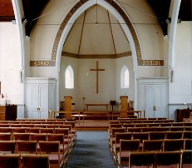
THE AVENUE
STANFORD AVENUE
METHODIST CHURCH,
BRIGHTON
October - November 2022

Minimum Donation 50p

THE AVENUE
Minister: Revd Dan Woodhouse Tel: 01273 508704
E-mail: revdanwoodhouse@gmail.com
Church Office Answer Phone: Tel: 01273 554141
E-mail: stanfordmethodist@btconnect.com
Assistant to Minister: Major Connie Croly: Tel: 01273 875376
Editor: Martyn Coblenz: Tel: 07724 605610

A Letter from Andy Lowe – Superintendent Minister.

Dear friends,

Just recently I watched a video of an American preacher called Francis Chan. The video is one of a number of videos that come from a website called stopandthink.com which is designed to make people stop and think about life, faith and the meaning of the universe.

In the video he was speaking of how we need more often to stop and think because far too often we don’t, we take things for granted, life just goes on and on and we fail to think about what we are doing and why we are doing it.

Towards the beginning he says something like
“Stop and think about the fact that you and I are standing on a giant ball that is spinning at a thousand miles an hour, am I the only one who thinks this is weird? And the fact that we’re flying around this ball of fire that is a million times our size and we’re flying round it at sixty seven thousand miles an hour and we just go ‘Yeh, it’s just another day.’ It’s not just another day, there’s nothing normal about it. This place is amazing, it’s gorgeous.”

Well I think that is pretty amazing and we do often take it for granted. The delicate balance of life, the beauty that we see, the sights that amaze us, the power of the surging seas, the sunsets that sing to our souls. We live on an amazing world which is part of an amazing universe.

For Christians, especially around Harvest time, and for many people of faith it makes us want to sing of the greatness of God

Yes, God is good – in earth and sky,
From ocean depths and spreading wood,
Ten thousand voices seem to cry:
‘God made us all, and God is good’.
John Hampden Gurney (1802-62)

But when we look round at the world and its peoples the view is not always good. We see pollution of seas and rivers; we see the misuse and waste of resources and we hear the noise of conflict and war. And although it saddens us, we scarcely give it a glance, we take it for granted as it has been it always will be.

Well again that is not how it should be and just as people are moved by the beauty and want to praise so too people of all faiths and none are moved to work for a better world.
Fred Kaan (1929-2009), another hymn writer, wrote

But also of need and starvation
We sing with concern and despair-
Of skills that are used for destruction,
Of land that is burnt and laid bare.

It is not enough for us to praise God and give thanks for the blessings in our lives. More is demanded of us as members of the human race let alone as believers in God and followers of Jesus Christ. ‘There can be no thanks without giving’, Kaan writes in one verse in one of his hymns. Our words of praise need to be backed up by our care for creation and our fight for the planet and all humanity.
We need to be people who write letters to Governments and institutions, we need to be people who re-cycle all we can. And in this time of cost of living and energy prices rising we need to have compassionate hearts that reach out to each other and all people and help in whatever way we can, people on the margins, people who are in need, we need to stand up for a world that our children and our children’s children will live in that it may still be a place where they will catch sight of beauty, where they will be able to drink clean water and enjoy what the earth provides. May God’s generosity make us so thankful that we will work for a better world.

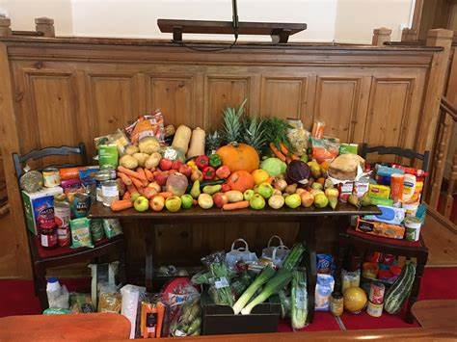

In Christian love,

Andy

Martyn – Thanks Andy for this & stepping in at short notice. Much appreciated.

Calling all Ladies from 18 - 118!!

I hope you will have heard about our ladies night fundraising event
on Friday 14th October. We will be having exclusive access to a show of good quality high street and boutique fashion ladies clothes.
(The models may look surprisingly familiar!) and afterwards, if
anything takes your fancy, there will be an opportunity for you
to buy them at greatly reduced prices! You will be able to try the
clothes on and all major credit cards are accepted.

We do hope you will be able to come to this event, as there
promises to be something for everyone, whatever our age and shape!

It will be held in the Church and tickets cost £6 to include a drink on entry, and snacks will be available.

Tickets can be bought in advance from Liz on 01273 430508 or email:
ticketsforstanford@gmail.com

We would love to see you all at this event…and why not bring a friend?

The Fundraising Team

THE WITHIES – DOREST.

I thought I would add this item so that anybody wanting to get away for a couple of days would have the opportunity to stay in this part of the country and an exceptional Bed & Breakfast.

What is on Offer
Under new ownership and exclusively for adults we aim to maintain a high standard of hospitality & service, with off-road parking and Wool railway station less than a ten-minute walk away. We also offer secure cycle storage.
The area abounds in forest trails, coastal paths, and amazing flora and fauna perfect for cyclists, walkers and lovers of the great outdoors.
In close proximity to both Monkey World and the Tank Museum. There are bus links to Wareham, Poole, Dorchester, Weymouth and Lulworth Cove, we are ideally situated as a base to explore.
We want you to be as comfortable, cared-for and relaxed as possible ensuring your stay with us in this beautiful part of Dorset is a lasting memory.

Bedroom 1

Bedroom 2

Both Lis & Myself had a really great stay here and our hosts (Andy & Chris) could not have been more friendly & welcoming. They were always willing to help in any way and their home facilities were exceptional.

We fully recommend them to everyone even if you wish to use them as a stopover to somewhere else.

For those who have access to the internet, please click on the following link - https://thewithiesbandb.co.uk/

CHURCH FAMILY NEWS

We continue to pray for June Lawson, Nadine & Gary Pugh, Ann Collins, John Pollard (Vic & Margaret’s Son), Sylvia & Ray Smith, Debbie Johnson, Jean Griffin, Doug Butler, Liz Wakeling & Amy Codling (Leaders of Scouts & Girls’ Brigade), Phil Codling, Ian Codling, Maureen Knell, Sheila Whyte, Jean & Geoff Starks, Wynn Funnell, Gill Challen, Margaret Trengenza, Pam & Norman Challis, the family of Brenda Nurcombe.
It is also with sadness to report the passing to higher duty of Shirley Challen. We pray for Karen and all the family in this time of sadness. The funeral will be held at Woodvale Crematorium on Friday 7th October @ 11:30 am.

As always, please let me know if you want me to remove any names, add to them or update us with news of any of the above.
We of course continue to pray for our Circuit staff as they minister to us – namely – Revd’s Andy Lowe, Deborah Cornish, Dan Woodhouse, Heather Leake Date, Major Connie Croly, Sue Harrington, and all our Lay Workers and Local Preachers.

IVOR CHALLIS

I have never been asked to write a eulogy before so naturally I approached a source of reliable help and advice that has always been available to me for more than two decades now. Google.
Google told me firstly that a eulogy should be factual. This meant that my initial notes, which like every child’s view of their father, described him as mixture of fifth Beatle, Superman and Mafia Don, had to be discarded. Although perhaps a little more on that last one later.
Google’s second suggestion was that a eulogy should be chronological and include anecdotes about their life.
This left me struggling again as dad was never very talkative and I know very little detail about his life beyond broad themes:
- Dad was born in July 1935
- During the second world war, he and my grandparents moved in with my great grandparents to a place called Eaton Soccam in Cambridgeshire
- After the war the family returned to Croydon before eventually moving to Worthing when my grandfather retired.
- Dad met mum at a harvest supper held at Offington Park Methodist Church and they were married in April 1973.
- I was born in September 1977 and in late 1979 we moved to Ditchling Road in Brighton, an intended short-term home, in which they still lived, almost 43 years later.
- Dad trained as an estate agent which he certainly enjoyed, and he remained an avid reader of the property pages in the Argus to this day. However, the development of the profession through the 1980’s was not to his taste and at the end of that decade, after a short period with the court service, he was lucky enough to find a job he truly loved as an assistant at the Booth Museum.
- Surrounded by dinosaurs and natural history he worked to retirement engaging members of the public of all ages with his knowledge and passion as someone who genuinely loved his job.
- Retirement in 2000 did not initially suit dad and it wasn’t long before he found a part time job putting out chairs at a local playgroup. The effort of walking the better part of a mile each way, twice a day for what can only have been very modest remuneration did not trouble him at all, he was simply happy to help.
- From 2000 dad lived a quiet life, he continued coming to church, he and mum went on occasional coach trips both near and far, including a trip to Senegal, of all places.
Just like schoolteachers, parents are just “there”. To their children they are parents, they are not real people with hopes and dreams, ambitions or disappointments and I had never thought about dads life before.
It struck this was a very quiet life and there should be more to say about someone who lived to 87. There should be more adventures, more anecdotes, more brushes with the law.

I confess I was a bit stuck, but inspiration came from an unexpected source in the form of the man himself and the introduction to his Will
“I would wish that there be no mourning for me as apart from a few isolated incidents, by the grace of god, I have lived an entirely happy life and trust that I may serve him better in the life to come and so wish that my memorial service be a joyful time of praise and thanksgiving”

I have lived an entirely happy life. What more can anyone ask for?
This encouraged me to reflect a bit more carefully about dad and his quiet life. I was reminded of the conversation with the kind lady from the hospital who telephoned me to say that sadly there was nothing further to be done and I should make arrangements to come to Brighton as soon as possible.
She explained she had had a long conversation with dad and that he was not afraid or sad, his faith would carry him through, and he was excited to know what came next.
Meeting your passing not with fear or regret but with excitement for the next adventure after long and entirely happy life. Can anyone really ask for more?
So, I thought again about his quiet life, apparently bereft of adventure and anecdote. I thought about his interests – dinosaurs, science fiction.
It is true I don’t think he ever boldly went where no man had gone before and I am sure he was not asked to consult on the construction of a live dinosaur theme park in the Caribbean but with his own words in my head, I don’t think that matters. His quiet life touched many others in many ways, and he will be missed, again both by those near and far.
He was whimsical in his own way. Christmas day services at Stanford Avenue will be less colourful now. The line of children between 5 -10 years old excitingly showing off their favourite piece of plastic received that morning would seem a little less joyous now that my dad (86 years old last time round) won’t be at the end of it with his own latest piece of dinosaur paraphernalia.
He capacity for trying to help knew no bounds. Regular attendees at church sales will remember his book stalls. I will certainly never forget the backbreaking hours carrying very heavy trays of books from house to car from car to church from church to car and from car to home, likely to be repeated only a few weeks later.
Many, many times did I complain the effort involved in this was simply not worth it given the likely takings were rarely more than £30 and somehow, we always ended up with more books than we started with. Dad would always smile and point to the £30 as being very much worth it.
As far as he was concerned if some good was done, the effort involved was justified no matter how great. Can that view be criticised? Now that I am older and supposedly wiser, I’m not at all sure it can.
Now, as promised, a little more about dad’s brushes with the law. Anyone who has ever (foolishly in my view) accepted a lift from dad will know his driving style might charitably be described as “bold” and more accurately described as “reckless”.
Give way lines and traffic lights were always regarded as advisory only. Advice which was routinely ignored altogether.

Despite this, I am only aware of one speeding ticket. He was obviously not entirely scrupulous as rather than admit this to mum, he kept quiet and intended to pay it off, but not before writing to the Evening Argus to complain about the unfairness of it all. Naturally the letter got published and mum learned about it there. That was a few years ago so perhaps he learned to hide his tracks better.
Going through some of his papers, I discovered correspondence with Asda about a parking ticket issued when he overstayed the allotted 3 hours. Rather than just pay up, dad had replied to explain he had found the new layout of the shop quite overwhelming and so had decided to take a short nap on returning to his car. This short nap turned into a long nap, leading to the ticket.
I imagine any number of excuses have been offered in mitigation against parking tickets, but the tone of Asda’s reply was this was a new one and his appeal was successful.
More recently he reversed into another car close to home, refused to accept mums pleas that is what he had done and simply drove off. A few days later a young lady knocked on the door to say someone had reversed into her, but she didn’t take their number plate and without that the police could not help but had suggested she knock on doors to see if anyone had CCTV of the incident. Mum answered and admitted that while we didn’t have CCTV, she might well be able to identify the culprit….
So, there we have it. Ivor Lewis Challis 29 July 1935 to 12 August 2022:
- A man of strong faith
- A kind man not without humour
- Career criminal
Who knew?!

Martyn – Thanks Norman, your Father was a truly remarkable & Christian man which I had the privilege to know for many years.

++++++++++++++++++++++++++++++

If I was asked to sum up the life of Ivor in a few words, as I have been today, I would say that he was a great example to us all of a Christian gentle man, in fact I would add one other word to that statement, a great example to us all of an “Ecumenical” Christian gentle man. Ivor died to live on the 12th August aged 87, and although a dedicated and committed member of the “family of Christ” here at his Church. Over the years both Ivor and Pam have supported many events at our St Matthias Church just up the road, and often worshipped with us, particularly over the past years through the Covid pandemic, and more recently they regularly attended and enjoyed our “Time Out Together” meetings in our Church hall on Friday mornings, enjoying a time when we meet friends and neighbours, a place where all are welcome.

A few years ago when we used to organise European Tours every year at our Church, Ivor and Pam would often join us, and I have fond memories of them enjoying those trips to the Christmas Markets in Germany each year, and other tours all over Europe. They both loved to travel and wherever they went on holiday together, Ivor always sent us a postcard without fail.
Ivor regularly attended Bible Study Prayer Group I used to run at my home. He rarely ever missed a meeting. He would turn up with one of the most thumbed Bibles I have ever seen, sit in his favourite chair and sometimes appear to “nod off” although when we paused for discussion he would be right there “on the ball” with some valuable and well informed input.

Although a dedicated Methodist I saw him very much as an ecumenical Christian, always keen on Christian Unity. Sometimes I think he was as much a part of our Church as yours. Over the years he played an active part in “Churches Together in Preston” until it disbanded, and he was a very keen supporter of the “Good Friday Walk of Witness” every year. Every time you published a magazine at this Church he would, without fail, walk or drive round and put a copy through our letterbox, right up until just before his death, rather like our late Queen, faithful to the end.

For Ivor I don’t think there were any labels or “denominations” in the Christian Faith, we were to him all brothers and sisters in Christ, which I, who started my journey of faith with the Salvation Army in Dartford, Kent in 1949, becoming a Lay Minister in the Church of England, firmly believe is how it should be. Ivor always enjoyed meeting with other Christians whoever they were of whatever denomination to study and talk about the Word of God.

It would be fair to say that the world has been richer for him having lived, and the poorer for his passing. May he now rest in the light and peace of God’s Eternal Kingdom in which he so very much bore witness to and believed. Amen.

Thanks to Dave Brooks a Lay Reader at St Matthias Church, Brighton.

SHOEBOX APPEAL

I am well aware that many people are finding things a bit more difficult these days, but if you are able to help with this appeal again this year it would be great. It is not necessary for you to do a complete shoebox, unless you would really like to, but to perhaps donate a few of the items that are needed.

As in previous years we are asked to help either by doing gifts for a family or for an elderly person.

We are asked to put the following into each shoebox
Gloves or Scarf or Hat (new or knitted)
Toothbrush & Toothpaste
Sweets or Chocolates (BB June 2023 EU Origin)
Soap & Flannel
Candles & Holders – holder is for safety and stability
Small Games (Travel Size Draughts/Dominoes/ Playing cards)

I will leave some leaflets in the fellowship room, and you will be able to see what other items are suggested.

Please can I ask that any donations are brought in before the end of October so that we have the time to make up the shoeboxes before delivering them to the warehouse in Ferring.

Many thanks
Amy

7th Brighton Scout Group Autumn 2022

Here we are back in action after about 2yrs of on/off weeks due to Covid lockdowns or outbreaks!

Firstly we now have some 25 Cubs in our Cub Pack, and about 17 Scouts which is great. More wanting to join.

At the end of the Summer term Cubs and Scouts went on a visit to Shoreham Lifeboat Station, had a great tour of the boats and the gear that they need to wear on board, all the children seemed to spend in the souvenir shop. Worth a visit!

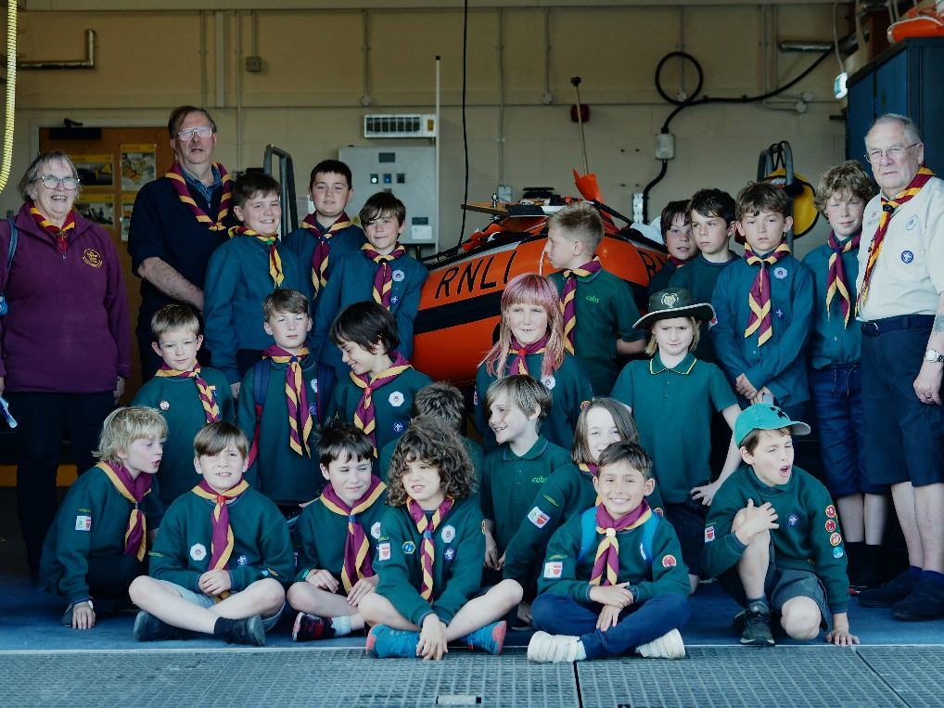

A few weeks later, the Cubs visited the RSPCA centre at Braypool, the ladies organised a short talk about pets, a fun quiz then they brought out some Madagascan Beetles for all to hold or let escape!!

This term we are planning to make bird boxes as part of D.I.Y. Badge. Could be fun?
So far this term we have done the District Cub Challenge at Parkwood and made some models for the Flowerpot Festival. Coming up is the Conker Competition, then the District Quiz.

Of course our annual Christmas Carol Service is booked for 6th December starting at 6.15pm. All are welcome, with mince pies and mulled wine to follow.

Liz Wakeling (Group Scout Leader)
7th Brighton Scout Group.

Martyn – Thanks Liz it’s always good to hear how the Troup is getting on & especially good as you have a waiting list.

WITH GOD EVERY DAY.

With God every day to begin again, to trust and feel his love for us
And know that in all of the confusion
There is a gift to be found

With God every day to hope for the best
To believe our prayers are being heard
That good news is on it’s way, that anything can happen
Between yesterday and tomorrow

With God every day to count our blessings
To remember whose children we are
And what we’re capable of
Through a Father who cares so much

With God every day to be made new, to forgive and heal
To do what we can and leave the rest to God.

Isiah 40:31

“But those who trust the Lord will find strength
They will be strong like eagles soaring upward on
Wings: they will walk and run without getting tired”.

SMILING.

Smiling is infectious
You catch it like the Flu
When someone smiled at me today

I passed around the corner
Someone saw me grin
When he smiled, I realised
I’d passed it on to him

I thought about that smile
Then I realised its worth
A single smile
Just like mine
Could travel round the Earth

So, if you feel a smile begin
Don’t leave it undetected
Let’s start an epidemic quick
And get the world infected!

MEDITATION & MUSIC.
The date of the next Music & Meditation meetings are :-

19th October

16th November

21st December

The meetings take place at 2-30 – 16-00 pm in the Fellowship Room.

Best wishes Sylvia Lord.
FUNDRAISING UPDATE.

If you missed our Flower Pot Festival with all the amazing sculptures, it was a fun event. The sculptures were varied and used lots of unwanted and unloved flower pots. We had visitors that had never been in the Church building before which are always interesting conversations. The most votes were for Pot a Pillar made by Cath and the under 10’s Molly learns to skip by Sunny and Melanie from Girls Brigade.
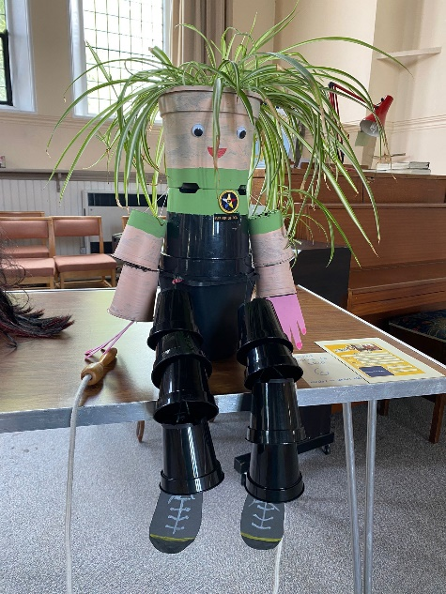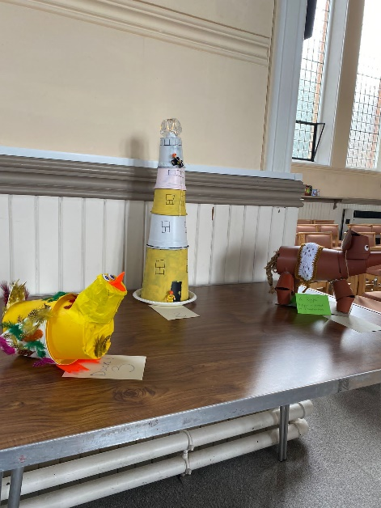

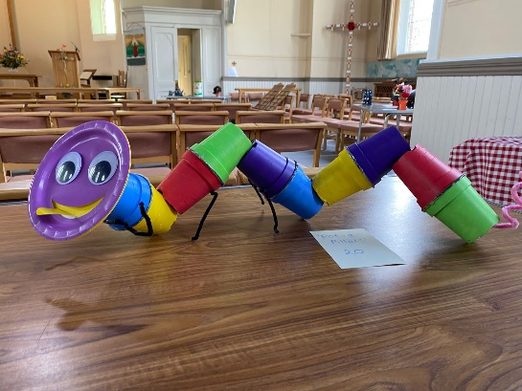
14th October – Fashion Show 6-30 for 7-00 pm. Last chance to get your tickets for this ladies only event. Call Liz Wakeling 01273 430508 or email ticketforstanford@gmail.com.
Tickets £6 to include a drink.
29th October – Quiz 4-00 pm. Entry £10-00 to include a ploughman’s and lots of cake. We are in for a treat as Robert and Martyn are able to take part as Pete Dilloway assisted by Lisa will be quizmasters.
26th November – Christmas fair 11-00 – 15-00.
We hope everyone is looking forward to this annual event. It is always a great fundraiser and an opportunity to meet with members of our local community. As always please look through those unwanted gifts and donate for the gift bags or gift stall. We will need sweets/chocolate and stationary items for the prize every time tombola. Our biggest money maker is of course the raffle so if you know any business or individual that would be willing to donate a prize (or two) that would be wonderful. Cakes on the day please.

2023 our Church is 125 years old, and we will be celebrating our Quasquicentiennal. We would love to hear your ideas, so please let any of the stewards or fundraising team know.

Many thanks from your Fund-Raising team.

LAST DAY for DECEMBER 2022 – January 2023 magazine contributions will be MONDAY 21st NOVEMBER.

You will be able to send contributions via E-Mail: stanfordmethodist@btconnect.com, or, by post to Stanford Avenue Church with ‘For Magazine’ on the front of the envelope.

WHO AM I?

My favourite TV programme is The Repair Shop

My favourite film is The Sound of Music

My hobbies were Embroidery & Machine Knitting

I have lived in the same house in Brighton for 63 Years

My ambition was to learn different languages

My favourite food is Fish & Chips

My favourite colour is Blue

My favourite animal is a Squirrel

My favourite country to visit is Switzerland

I was born in Sheffield

PAUSE FOR THOUGHT
On Tuesday 6th September I watched H.R.H. QUEEN ELIZABETH II with her new Prime Minister Liz Truss. The Queen looked a bit frail, but her wonderful smile and bright blue eyes sparkled as always. Two day later, on Thursday 8th September her majesty died, just 13 weeks after celebrating her Platinum Jubilee.
Over the past 2 weeks I’ve watched a great deal of the coverage on T.V. and been amazed at the huge crowds at all the events. I also watched a lot of the Queen’s lying in state. Until the early hours of the day of her funeral, people quietly filed past to pay their respects. Some just bowed their heads, others just stood a moment, many shed tears, military people saluted, women curtsied, some blew a kiss. They queued up to 14 hours for a brief moment to show their love for our Queen.

The Archbishop of Canterbury told us that the Queen didn’t think this was the end, that she believed in Resurrection. That she was a women of great faith in Jesus Christ. That she was rooted and grounded in her faith in Jesus Christ, and yet, wanted to be there for all people, and people of all faiths, and no faith.

The darkness falls at Thy behest
We thanks Thee that thy Church, unsleeping
While earth rolls onward into light
Through all the world her watch is keeping
And rests not now by day or night

The voice of prayer is never silent
Nor dies the strain of praise away
Hour by hour fresh lips are making
The wonderous doings heard on high

Her Majesty touched so many lives and will never be forgotten.

Now we have King Charles III as our monarch. A Christian man who watched his mother, and who he loved deeply.
May he reign with God’s help.

Life goes on, we too are on a journey. Death is not the end, so we go into the future with our Lord, in faith and joy.

May God bless us all. As I said in the last Pause for Thought, we must keep on praying. We need to pray for each other.

Hour by hour fresh lips are making the Lord’s doings heard on high. Let us be part of his praying people.

Amen

Wynn

Martyn – A very touching piece Wynn. Once again, a huge thank you for adding your thoughts especially during this time of mourning for the whole country and also in the world afar.

CONTRIBUTIONS NEEDED.
Please, please, please send me your items for the Church Magazine. Especially as Wynn has finished her item on being a Red/Bluecoat. I’m sure that some of you have some very interesting stories or items that others would be interested in.
Please send them to the stanfordmethodist@btconnect.com or drop them through the Church letterbox.
ANSWER TO WHO AM I.
BETTY BOSSINGHAM
Look out for the next one in the December/January issue.

DATES FOR YOUR DIARY.

14th October Fashion Show for the Ladies
29th October Church Quiz & Ploughman’s
1st November All Saints Service 19-30
13th November Remembrance Day Service
26th November Christmas Fair
27th November World Aids Day Service (Dorset Gardens)
6th December Cub/Scouts Carol Service
18th December Carol Service 18-00

advert
h b c
For bathrooms

195 Church Road,
Hove BN3 2AB
Tel: 01273 730149
Fax: 01273 207438

For top quality bathrooms & showers, retail only or full design & installation
(family business)
Directors: Michael Bellis, Marilyn Bellis & James Houldcroft

ACTION ROOFING SERVICES LTD.
Specialists in all types of Roof Renewals & Repairs
Tiling – Slating – Felting/Asphalting
Free Estimates
12,Plainfields Avenue
Brighton BN1 8RJ
Telephone: 01273 555535
www.actionroofingservices.co.uk
K. H. Tahsin

Retired decorator looking for a bit more work
01273 419914

We offer friendly, professional

care in your own surroundings
All our staff are fully COVID vaccinated
We are a local Fiveways family run company
We can help with
Washing and dressing
Making meals
Cleaning and shopping
Taking you out to an appointment

or out for the afternoon
▼
▼
▼
▼
01273 542200
www.hallifaxcare.co.uk
info@hallifaxcare.co.uk

