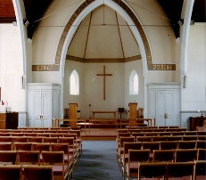***THE AVENUE***

**STANFORD AVENUE**

**METHODIST CHURCH,**

**BRIGHTON**

October - November 2020

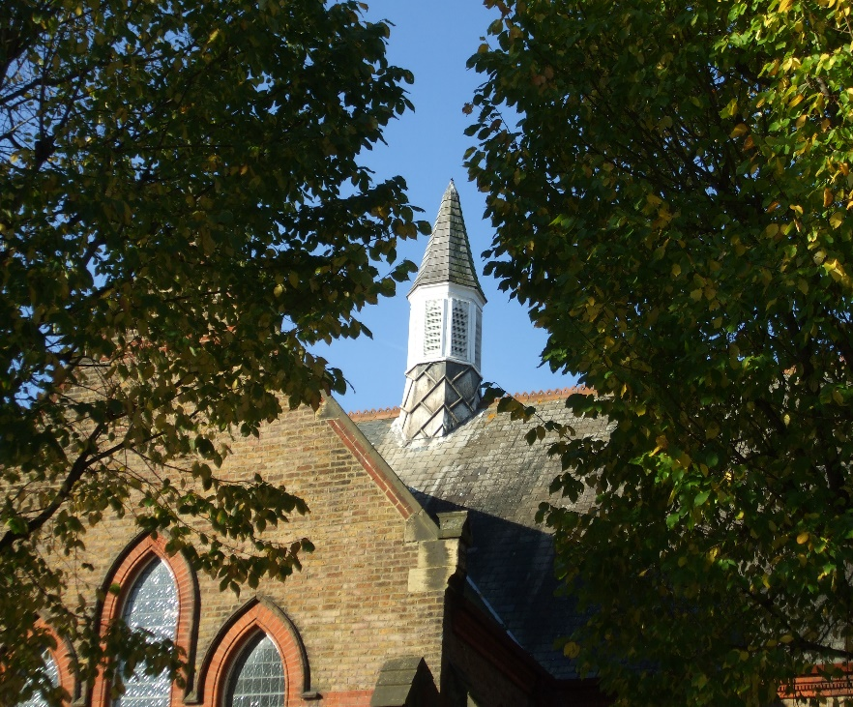

**Minimum Donation 50p**



My dearest Lord

Be now a bright flame to enlighten me,

A guiding star to lead me,

A smooth path beneath my feet,

And a kindly shepherd along my way,

Today and for everymore

**THE AVENUE**

**Minister: Revd Dan Woodhouse Tel: 01273 508704**

**E-mail: revdanwoodhouse@gmail.com**

**Church Office Answer Phone: Tel: 01273 554141**

**E-mail:** [**stanfordmethodist@btconnect.com**](mailto:stanfordmethodist@btconnect.com)

**Assistant to Minister: Major Connie Croly: Tel: 01273 875376**

**Editor: Wynn Funnell: Tel: 01273 556444**

**The price of everything and the value of nothing**

I supported a couple of people to attend a funeral this week. It was a fairly long drive there and back and so we could chat in the car. We talked about life, the life of the person and life in general. We talked about death, the death of this person and how the knowledge of death affects us all; for better and worse. We talked about funerals and the experience of going to them.

We live in a world where everything has a price but value is usually disregarded. We might say that some politicians and business leaders know the price of everything but the value of nothing. In a world where capitalism rules it’s no surprise that things of value are left to places like the church, and I’m sure many other sometimes disregarded places too.

There’s no gain in going to a funeral if time is money; with the exception of the funeral directors themselves! All that can be taken and given to a funeral, for everyone else, is value.

The person for whom the funeral was for was at the bottom of the pile, they had little status and were side-lined and dismissed regularly. They were a burden if all we care about is price.

However, their value was immense. First because they are a person with all the immense value this bestows. Second, they were deeply valued by those who attended the funeral.

I heard about different parts of the funeral service, what people said and so on, and attended the small wake afterward. People talked about the person, many things good, some things frustrating. They painted a picture of their friend. They mourned his passing and celebrated his life. All of which added something to the deceased as well as to those who live on. Perhaps we could call it dignity, but I don’t think any word quite sums it up. What I felt was a deep sense of value. Something I cannot buy, or sell.

The reason why things of value are difficult to monetise is because they cannot really be quantified or often explained. I came away from that experience, even though it was an experience of being slightly on the edge, feeling enriched as a human and feeling like the deceased had also been enriched. At the very least enriched in our memory, but perhaps also in far more incomprehensible ways that are far beyond us.

Last time I wrote in this magazine I was trying to write about prayer and having a tough time of it. This week’s experience has helped me focus a little.

Of course, it’s very difficult to understand the reasons why we pray because prayer has so much value but not any element that can be easily pinned down; certainly not monetised! (Unless, of course, you are a priest in the middle ages who lied about what prayer was in order to monetise it. Though, in these cases prayer ceased to have any value to the priest and was no longer even prayer.) So, what is the point of prayer? Well, I still don’t really know, by which I mean I know it has value but I can’t say what the exact, or even rough, output will be from the person putting time and energy into prayer/

Thank you to those who contacted me to share their thoughts on prayer. They were helpful to hear and heart-warming to discuss.

The common theme was value, though that word probably wasn’t used. I heard about different experiences of prayer that led to all sorts of things, some subtle and others, occasionally, miraculous. As for myself, I often look for a sense of peace and think this is the point; if I’m at peace I can handle the world and maybe occasionally something miraculous might happen. However, I’m never really sure what prayer will bring me, if anything at all.

Therefore, the most sure thing I can say about prayer, and what comes across in the conversations, is that prayer has value like a friendship has value. I have a few very close friends and I visit them when I can. I visit them at all kinds of different times and in all kinds of different states of being; sometimes full of energy, sometimes I’m not, sometimes I’m happy, sometimes I’m depressed, sometimes I even see friends and for various reasons wish I’d stayed at home. What I don’t do is sit down and work out the optimum, time to visit them for maximum gain. I don’t work out how much energy will be required and if the output will be worth it. I just go because friendships have an intangible value that is worth making room for.

So, if I were to say what the point in prayer is, I would say that prayer, spending time with God, has an intangible value that is worth making room for. I guess secondary to this is the things we ask for and hope that God can provide. However, the latter is not why we keep going back to prayer. As, just like a friendship, we might go thinking about our needs but come out the other side thinking about theirs instead, or even having got nowhere. This is because, as we know, God doesn’t fulfil all of our needs or desires at the moment of asking. God does not have a price tag. God does not have an expected output from a known input. God has an incomprehensible value and so does prayer.

Funny reading this back, that maybe it was obvious to many of you already!

Finally, thinking about incomprehensible value, I want, to take this moment to thank Wynn for all of her hard work on this very magazine. She has decided to step down after 20 years of publishing it and I’m sure many of us have found great value in what she has put together over the years.

Wynn, thank you so very much.

*There’s no doubt about it Dan, this is the longest letter I’ve ever received from anyone over 20 years!! Wynn.*

**A MESSAGE FROM LORNA**

I hope you are all keeping well? I’m starting a new business venture with Flamingo Paperie (previously known as Phoenix Cards) and wanted to share the love with you all. Some of you might remember Faye used to sell their beautiful cards a couple of years ago.

With Christmas fast approaching (yes, I just mentioned Christmas!!) I have a great selection of Christmas cards on offer which you can order from your own living room!

I’ll have some brochures I can drop off to anyone interested so just give me a call or pop me over an email or text.

I will also have some sample cards and a small selection of birthday cards you can look at and purchase too, and all from your own doorstep!

Eventually I will have a website up and running which, you can order direct from so will keep you all posted in the church weekly news.

Hope to see some of you soon

Lorna x

**LUNCH CLUB**

Sadly, once again, we will not be able to hold our Lunch Club for a while because of the Coronavirus.

Josie and Christine will get in touch with all the members when we can safely return and enjoy each other’s company, as well as the great food.

In the meantime, stay safe.

Christine Hall.

Usually at this point I would type our Church Diary for the next two months, but as no services or meetings are allowed to take place there is nothing to print. It seems very strange for us all, but the Coronavirus stops us! I’m sure we will all make sure that when we can eventually get together again, we will have a great celebration. In the meantime, we will phone, text and maybe even write to each other. Above all we will hold each other in our prayers, and pray it won’t be too long before we meet again. *W.*

**CHURCH FAMILY NEWS**

In case some of you have not heard, we start with the good news that Jean and Geoff are now Mr and Mrs Starks. I’m sure you join me in wishing them Congratulations and every happiness in their future together.

We continue to pray for Joyce & Bob Lawson, Joan Dengate, Nadine & Gary Pugh, Vic Pollard, Sylvia Smith, Debbie, Jean Griffin, Harold Cozens, Paul, Abbi, Liz Wakeling, Maureen Knell, Sheila Whyte, Syd Beck, Jean & Geoff Starks, Shirley and Gill Challen.

As always, please let me know if you want me to remove any names, add to them or update us with news of any of the above.

We, of course continue to pray for our Circuit staff as they minister to us – namely – Revd’s Andy Lowe, Deborah Cornish, Dan Woodhouse, Heather Leake Date, Major Connie Croly, Sue Harrington, all our Lay Workers and Local Preachers.

W*ynn*

**THE PENMO FILM CLUB**

**Woodingdean Methodist Church Hall**

**Penmo is closed for the foreseeable future.**

**As soon as possible we will start up again.**

**Any queries ring 01273 307496**

**FUND RAISING UPDATE**

It is highly unlikely that we will be able to have any fundraising events at the Church for some time but we will still need funds to help with the upkeep of the Church. Future events will have to be different so when we had our planning meeting via Zoom, we tried hard to think of ways to make money.

ZOOM QUIZ – Friday 16th October – We are aware that those of you without access to a computer will not be able to join us but hopefully those of you who can, will! The wonderful thing about a Zoom quiz is it does not matter where you are, if you have Zoom downloaded you can join in the fun! There is no prize but anyone interested please email [liscoblenz@yahoo.co.uk](mailto:liscoblenz@yahoo.co.uk) or call 01273 556366 to let us know so we can give you the ID. Family and friends welcome. To make it a fund raiser we would need a donation to the Church.

MAIL ORDER CHRISTMAS FAIR – Always a great day. I’m sure you will miss this event which always brings so many of us together. So, you can get some of your usual Christmas bits we are producing an order form with all the items available. Ann C. has been busy making stocking fillers and others have craft items for sale too. Can you help? Cakes? Preserves? Or plan is to list items to be ordered by November with all orders to be delivered by 13th December. Order forms coming to you very soon.

Got any good ideas for fundraising at this time? Please let us know.

From your fundraising team:

Keep safe and well from Karen, Amy, Mags, Liz, Jeni, Pete & Lis.

**A.F.C Home Collecting Boxes**

Due to the great response to the appeal, &636 – 18 was raised.

Thank you all so much for your generous donations, and for making them by cheques,

In these difficult times this amount will enable the Charity to relieve problems of many families and young people.

*Margaret.*

***GOD’S BILLBOARDS***

1. *Let’s meet at my house on Sunday before the game.*
2. *What part of “Thou shall not” didn’t you understand*
3. *We need to talk*
4. *Will the road you’re on get you to my place*
5. *Follow me!*

**KEEP LAUGHING**

***My mother, who is 93, lives in sheltered accommodation. Even though she has ample savings, she is always worried about the state of her finances. My brother-in-law tried to ease her mind by telling her, “I’ve worked out that, given your expenses, you have enough money for at least the next 16 years”. “That’s fine,” mum replied, “but how will I manage after that?”***

***Both full-time students, my son and his wife don’t have time or money for anything other than studying. I was with them in church one day, when the vicar gave a sermon on marriage.***

***The three most common problems that can lead to divorce” he warned, “involved money, children and sex.” My son whispered to his wife, “Then we should be OK, we don’t have any of those.”***

***My 4yr old grandson always managed to answer the telephone before anyone else. On day I decided to see if he recognised my voice. After he answered, and I said “Hello Daniel, who am I?***

***This was followed by a short silence, then a shout: “Mum! Nanny’s on the phone and she doesn’t know who she is.***

***An old friend and I were on holiday in Israel and decided to take a trip on the Sea of Galilee. The boat operator told us that it would cost £35. My friend was astounded and told the operator so.***

***“But these are waters on which Christ Himself walked” the man replied, “If that’s how much it is to take a boat, no wonder my friend replied.***

**\*\*\*\*\*\*\*\*\*\*\*\*\*\*\*\*\*\*\*\*\*\*\*\*\*\*\*\*\*\***

**LAST DAY for DECEMBER/JANUARY 2021 magazine contributions will be WEDNESDAY 18th NOVEMBER**

Hopefully we will be meeting as usual by then so I will be needing details of meetings. You will be able to send via E-Mail: [stanfordmethodist@btconnect.com](mailto:stanfordmethodist@btconnect.com), or, by post to Stanford Avenue Church with ‘For Magazine’ on the front of the envelope.

Thank you as always to everyone who has contributed to this magazine. If there is anyone who in the past has thought about writing something don’t just think about it….DO IT!!

In case you’ve forgotten there is a pigeon - hole in the Fellowship Room so feel free to put articles etc in it or give them to me, when we re-open of course!

The above magazine I regret to say will be my last! Twenty years ago, I offered to take over from Gwen Beckerlegge for a couple of months and here I am twenty years later!

I have loved doing them. To start with we did one every month, now we do six a year! Lots have things have changed of course but even that has been challenging!

So, if there is anyone out there who feels they could have a go **PLEASE** let me or Dan know.

Thank you to all have contributed over the years, it’s been quite an experience. *Wynn.*

**A reminder** - We're not going to be asking for the usual £5 annual fee any more but will just ask for donations - plus the cost of any postage if applicable.

Thank You All Esther x

**TIME FOR A LAUGH**

***A friend usually called to see me after her slimming class. One evening, she didn’t turn up so I gave her a ring. “The instructor was off sick, she explained, so all went pear shape.***

***Determined to get rid of a wasp nest in the garage, I thought of poking it with a stick. When I mentioned it to friends, they were horrified and suggested I call the council. A pest control expert arrived and charged me a fee of £50. He observed the nest looked abandoned. Then he poked it with a stick!***

***On a shopping trip with a friend, we nipped into a small café for lunch. After studying the daily specials, we went to order. My friend fancied cheese on toast and asked the young girl behind the counter what kind of cheese it was. This perplexed the young girl, and after a few moments of intense concentration, her face lit up and she answered, grated.***

***Tearing myself away from the Olympic Games on television, I asked my 7-year-old son to let me know when the pole-vault competitor started his run up. A short time later, I heard a roar from the crowd and arrived to see if the athlete had made it. Yes, but he had to use a stick, he replied.***

***As he boarded the overnight train, the man said to the guard, I need to you wake me up in Edinburgh. I’m a deep sleeper and can be grumpy when I wake up, but no matter what, I want you to give me a call. Here’s £50, and the guard agreed. The man fell asleep and when he woke up, he heard the announcement that the train was approaching Aberdeen. Furious, he collared the guard, I gave you £50 to make sure I got off at Edinburgh! That man is really cross, said a passenger. I, commented his companion but not half as cross as the man they forced off the train in Edinburgh!***

**PAUSE FOR THOUGHT**

I wonder what you are doing during this time of lockdown to amuse yourselves?! I have been catching up on recordings that I haven’t had time to watch. Among them is a gem on BBC1 called THE REPAIR SHOP. It is an amazing show where people bring all sorts of precious things to be mended, restored etc. The people there are all very skilled in many things. Recently an 82-year-old man, Derek Leigh from Stockport was given an Art Deco handbag that was made of leather cloth. It was badly cracked with bits of material missing.

When his mother died at the age of twenty-five, he was still a baby. He grew up with his father and his present wife who he called Mum. His mother’s sister took care of the precious bag for 50 years, then his cousin looked after it for 30 years so, eventually it was given to him in a very sorry state. When he opened it, he found, inside 3 photos also in a sorry state, and, for the first time he saw what is mother looked like as she sat with him as a tiny baby on her lap. So, a very emotional Derek arrived at The Repair Shop carefully carrying the bag.

Susie, the expert on anything leather listened to his moving story, and assured him she would do her best to restore it back to its former glory.

Watching her work on it was quite something. She had to very carefully take it apart, giving the metal work to Bretton, an expert on things metal! She made an amazing job on it, as did Bretton with the metal frame. In the meantime, Jay, her brother and I guess the leader of the band of experts took the creased photo of Derek in his mothers’ arms and had it restored and framed.

Then cane the day when Derek arrived with his wife to collect the bag. You can imagine how emotional they both were.

Susie removed the piece of material covering the bag which really did look amazing. She had also attached a handle to it much as the original one would have looked like. Then, Jay produced the framed photo. At that point the tears came, mine too”.”

All he could say was “You are wonderful”. Then, a little later he said “I think now my mum is hopefully looking down on us and maybe saying – “Well done darling. It’s taken a long time but I think now we’ve finally found each other”.”

As I said, it was very emotional and moving for all who watched as well as those who had done the restoring.

I’ve found I’m far more emotional during lockdown, hence the tears watching said programme” How about you?

To quote a song, “What have you done to make you feel good?”

I’ve found that talking to the Lord throughout the day about all sorts of things vital. Having no one to talk to, not even a cat now, means I include the Lord far more than I used to! As some churches are re-opening, I’ve been able to conduct 3 services which have been a little different! No singing for a start, though I still often say as I announce a hymn, “let us sing, oh no, let us hum”!!

How have you adapted in this strange time that looks like going on for some time yet?

I pray that we remember one of my favourite hymns;

**What a friend we have in Jesus, all our sins and griefs to bear!**

**What a privilege to carry everything to God in prayer!**

**O what peace we often forfeit, O what needles pain we bear,**

**all because we do not carry everything to God in prayer!**

**Are we weak and heavy laden, cumbered with a load of care!**

**Precious Saviour, still or refuge – take it to the Lord in prayer!**

**In his arms He’ll take and shield you, you will find a solace there.**

(STF531)

So, keep safe. Keep praying.

Love and prayers.

*Wynn*

**advert**

h b c

For bathrooms

195 Church Road,

Hove BN3 2AB

Tel: 01273 730149

Fax: 01273 207438

For top quality bathrooms & showers, retail only or full design & installation

(family business)

Directors: Michael Bellis, Marilyn Bellis & James Houldcroft

ACTION ROOFING SERVICES LTD.

**Specialists in all types of Roof Renewals & Repairs**

**Tiling – Slating – Felting/Asphalting**

**Free Estimates**

**50, Patchdean**

**Brighton BN1 8LZ**

**Telephone: 01273 555535**

[**www.actionroofingservices.co.uk**](http://www.actionroofingservices.co.uk)

**K. H. Tahsin**

Retired decorator looking for a bit more work

**01273 419914**

**Hallifax Care**

h

c

**Friendly, professional care in your own surroundings**

**All your care needs provided by a local Fiveways independent company**

we can help with:

* washing and dressing
* making meals
* cleaning and shopping
* taking you out to an appointment

or out for the afternoon

**01273 542200**

[**www.hallifaxcare.co.uk**](http://www.hallifaxcare.co.uk)

[**info@hallifaxcare.co.uk**](mailto:info@hallifaxcare.co.uk)

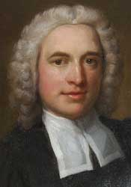

**Charles Wesley**

Charles Wesley is best known for his prolific hymn writing, his poetry and for being one of the founding fathers of the Methodist denomination of Christianity. He wrote more than six thousand hymns, of which a handful remain in modern day worship. He wrote the words to *And can it be*, *Christ the Lord is risen today* and *Love divine, all loves excelling*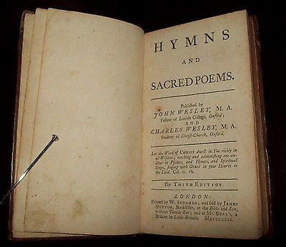





In troubled times

God of love,  
turn our hearts to your ways;  
and give us peace.  
Amen.